Stimulus aligned

Familiar versus Unfamiliar decoding rates minus chance (0.5)



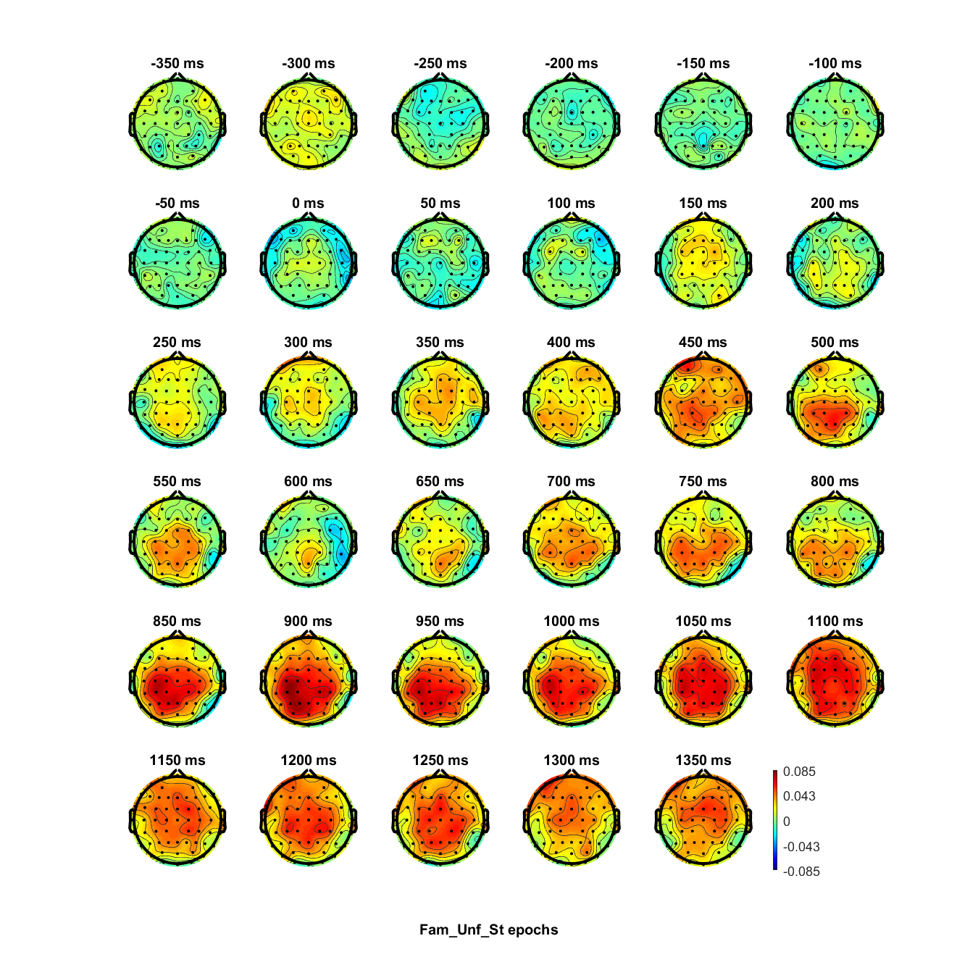

Response aligned



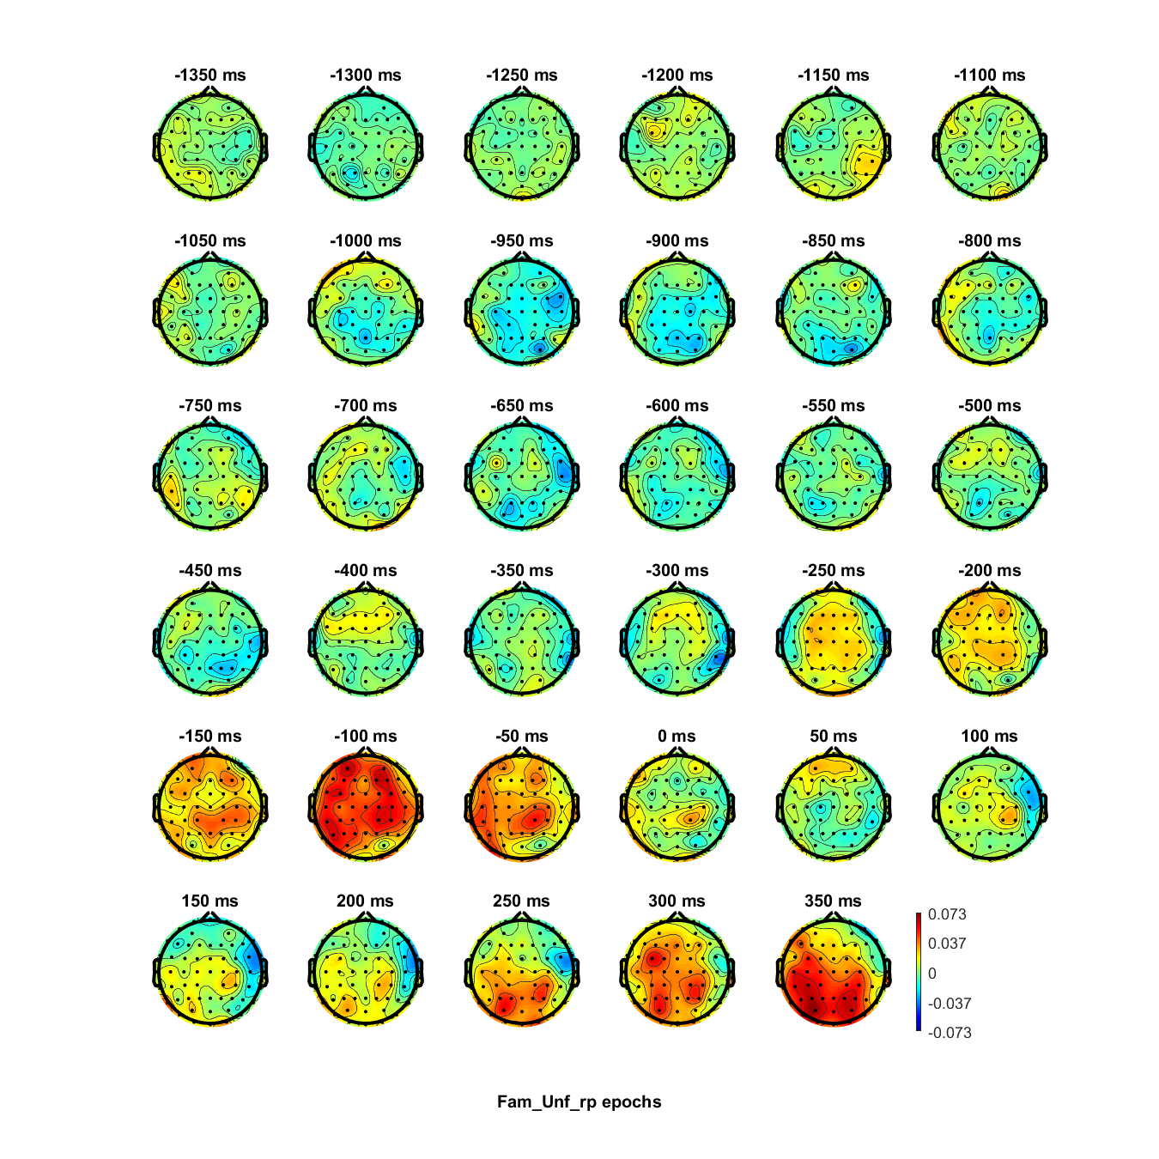

Stimulus aligned

0.22 versus 0.55 coherence decoding rates minus chance (0.5)



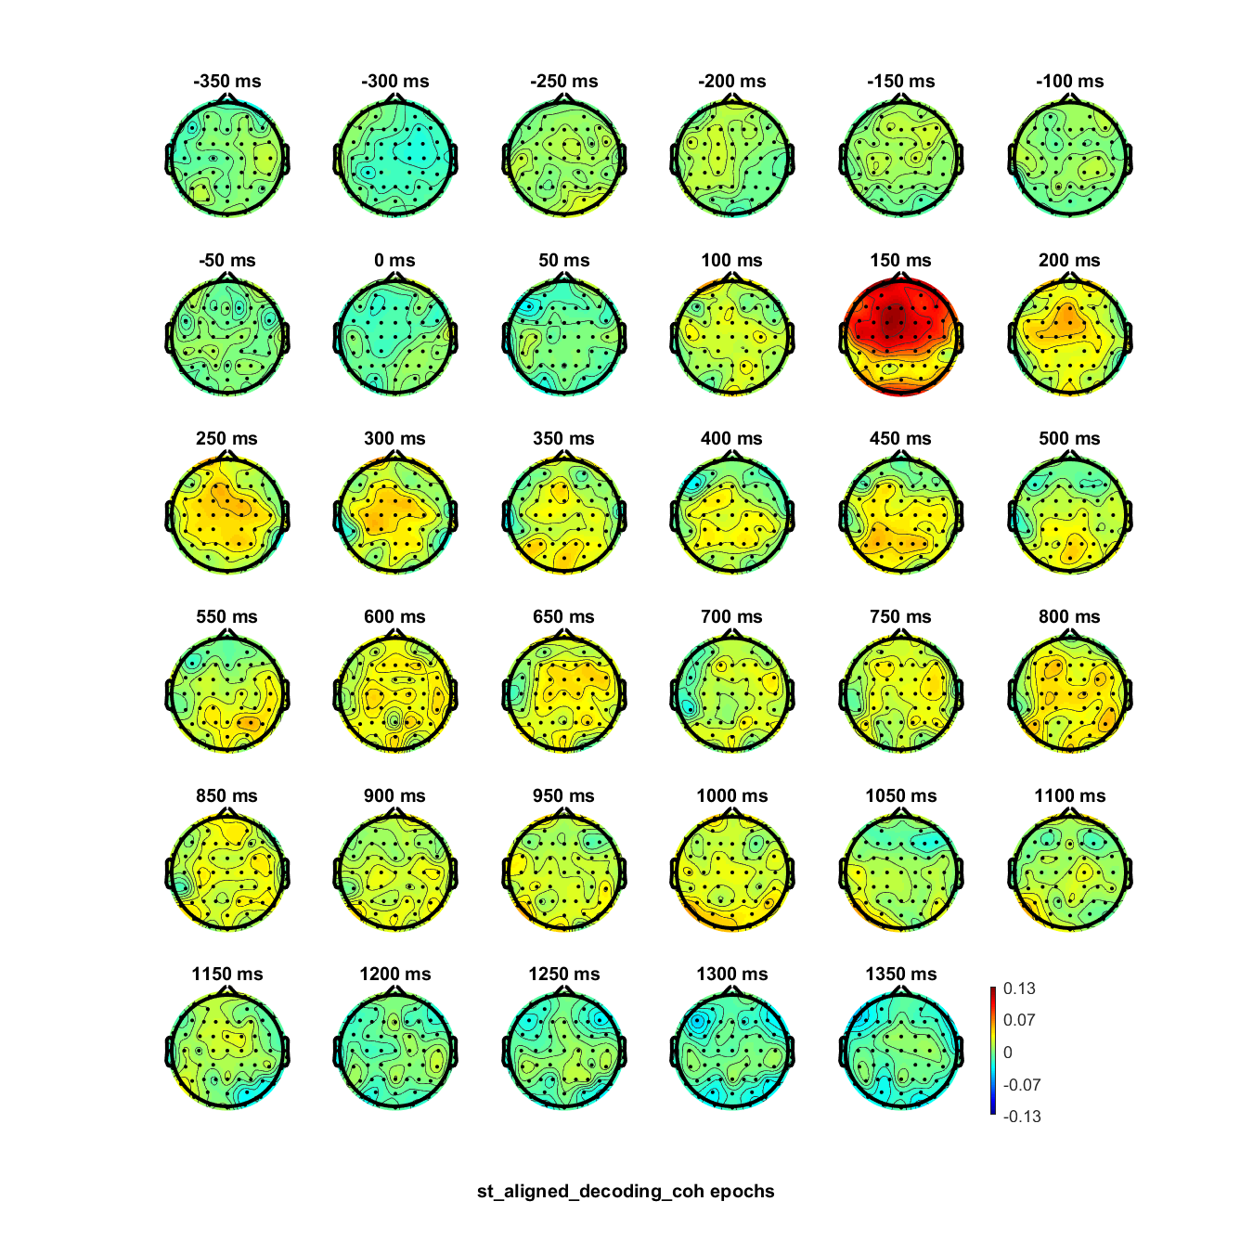

Response aligned



